Name ___________________________________

Shark Dissection

External Anatomy

- Locate and label the two dorsal fins, the caudal fin, the pelvic fins and the pectoral fins.

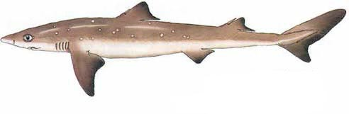

- What does it mean if the caudal fin is heterocercal?

- Locate and label the gill slits – How many does your shark have on each side?

- Locate and label the lateral line – What is its function?

- Locate and label the sharks nostrils – What is their function?

- Locate and label the Ampullae of Lorenzini – what is its function?

- Locate and label the spiracles – what is their function?

- Is your shark male or female? How do you know?

- Using the tweezers, puncture the eyeball and remove the lens. What shape is it?

Internal anatomy

- Using your scissors, make a cut up the ventral side of the shark from the pelvic fins to just above the pectoral fins. Be careful not to cut too deep.

- Locate the large liver – what is one of its functions?

- Locate the stomach and slice it open – notice the rugae lining the inside.

- Follow the G.I. tract to the intestines. Slice it open and locate the spiral valve – What is its function?

- Locate the cloacal opening (vent) – What three systems empty into the cloaca?

- Locate the heart just below the jaw – How many chambers does it have?

