Name_______________________________

Frog Dissection Instructions

 | Mouth Examination  - Locate the following parts: internal nostril  openings, gullet, teeth (small and large),  glottis, Eustachian tubes, tongue.  - Why is the tongue attached at the front of the mouth?  - What are the frog’s teeth used for?  - Where does the glottis lead to?  - Where does the gullet lead to? |  | 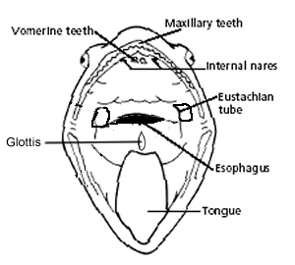
Internal Dissection

- Carefully cut open your frog. Use the
diagram to help locate and remove the
following parts: liver, lungs, heart, stomach, intestine, gall bladder, and fat bodies.

- How can frogs survive with such small lungs?

- Carefully cut open the stomach – did you find anything inside?

- Is your frog male or female?

- What do the fat bodies store fat for?

- Remove the eyes – what kind of eyesight do they have based on the shape of their lenses?

Match the following parts:

_____1. 3rd eyelid, used underwater A. small intestine

_____2. Eardrum B. large intestine

_____3. External nostril openings, breathing and smell C. tympanum

_____4. Opening of esophagus, leads to stomach D. kidneys

_____5. Opening of trachea, leads to lungs E. liver

_____6. Produce sounds to attract a mate, males only F. urinary bladder

_____7. Equalizes pressure behind the eardrum G. nares

_____8. Carries food to the stomach H. glottis

_____9. Stores food I. stomach

_____10. Digests and absorbs nutrients J. nictitating membrane

_____11. Absorbs water K. gullet

_____12. Receives feces, gametes, and urine L. cloaca

_____13. Exit from the cloaca M. mesentery

_____14. 3 large lobes, makes bile N. gall bladder

_____15. Stores bile O. gonads

_____16. Produces digestive enzymes P. pancreas

_____17. Holds internal organs in place Q. vent

_____18. Makes and stores blood cells R. vocal sac openings

_____19. Filter wastes from the blood as urine S. Eustachian tubes

_____20. Stores urine T. oviducts

_____21. Produce gametes U. esophagus

_____22. Carry eggs to the cloaca V. spleen

