Name ___________________________

Reptilia

- What does the word Reptilia mean?

- Explain how the reptilian heart is an advantage over the amphibian heart.

- What adaptations did reptiles develop to avoid dehydration?

- Why must reptile lungs be better developed than the amphibian lungs?

- What was the last obstacle to life on land that the reptiles had to overcome?

- What is the process of internal fertilization in reptiles called?

- Name and give examples of the four orders of reptiles

- Labe the amniotic egg below: albumen, allantois, shell, amnion, yolk sac, chorion, embryo

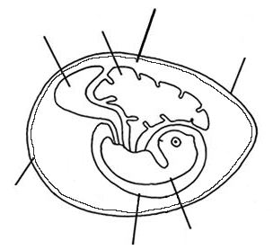

- Give the functions of the following parts of the amniotic egg:

Amnion –

Chorion and shell –

Yolk sac –

Allantois –

Albumen –

- Explain the difference between a turtle and a tortoise.

- Explain the difference between an alligator and a crocodile.

