Name ___________________________

AVES

- What is the study of birds called?

- What is THE trait that distinguishes birds from all other animals?

- How does the number of species of birds compare to other classes of vertebrates?

- Next to each statement, write whether it is describing altricial or precocial birds.

____________________ less parental care

____________________ lays 10-20 eggs

____________________ hatch out helpless

____________________ tend to nest on ground

____________________ lay less than 6 eggs

____________________ more parental care

____________________ hatch out better developed

____________________ tend to nest in trees

- Name two examples of altricial birds.

- Name two examples of precocial birds.

- Label the parts of a feather:
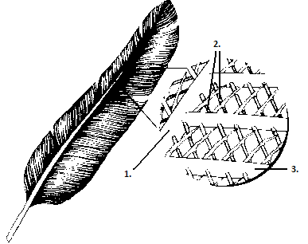

- Name and describe 3 types of feathers

- Give two examples for each of the general types of birds:

Waterfowl –

Raptors –

Flightless –

Songbirds –

Upland game birds –

Shorebirds -

- What is preening?

