Name _________________________________

PORIFERA

- What does the word “Porifera” mean?

- What is the common name for poriferans?

- How do poriferans compare in complexity to other animals?

- Label the sponge below: ostia, osculum, spongocoel, collar cells, amebocytes, spicules, epidermis

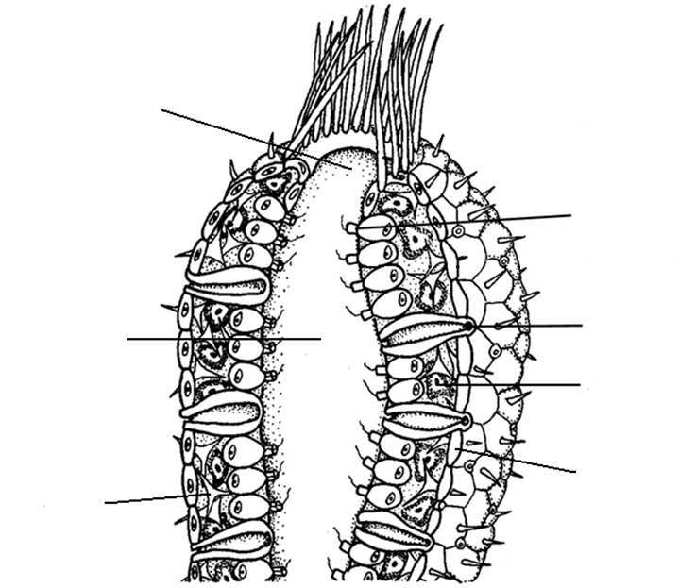

- What is meant by sponges being sessile?

- Why do sponges circulate water through their bodies?

- What is meant by regeneration?

- Name two other methods of asexual reproduction in sponges.

- Explain how sponges reproduce sexually.

- Match the following sponge structures:

_____ incurrent pores A. amebocytes

_____ excurrent pores B. collar cells

_____ the outside covering cells C. epidermal cells

_____ the skeletal structures of a sponge D. osculum

_____ flagellated cells that create the current E. ostia
of water, capture and digest food, and
become sperm F. spicules

- How are sponges classified into classes?

- Name the four types of sponges

