Clam Dissection Name _______________________________

Pre-lab Questions
- Name the Kingdom, Phylum, and Class for clams.

- What does the term bivalve mean?

- Do clams show cephalization? Explain.

- Name 3 examples of bivalves.

External Anatomy
- What is the oldest part of the clam’s shell called and how do you locate it?

- What do the rings on the clam’s shell indicate?

- How old is your clam?

- What are the functions of the tooth-like projections along the edge of the clam’s shell?

- Label the anterior, posterior, dorsal, and ventral sides of the clam shell.

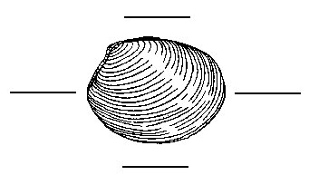
Internal Anatomy

- What muscles open and close the clam shell?

- How do clams breathe?

- Describe the purpose of the two siphons of the clam.
- Incurrent siphon –

- Excurrent siphon –

- Are the siphons located at the anterior end or the posterior end of the clam?

- Where are the palps found and what is their function?

- What type of digestive system do clams have?

- Can all bivalves make a pearl?

- Describe how pearls are made.

- Label the internal parts of the clam.

