Analyzing Data

- Units – Language of Science
- SI system (____________________) – standard unit of measurement

- There is only _____ base unit for each thing measured
- Length =
- Weight =
- Volume =

- How big are they?
- Meter - | 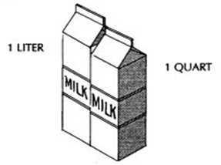
- Liter -
- Gram -
- Measured in multiples of ___________

- Prefix -

- 6 Common Prefixes

Prefix | Symbol | Number
Base Units (meter, liter, gram)

- Decimal Moving

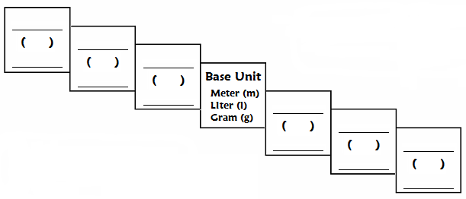
Conversion steps:
- Find your ___________ point and ___________ point
- Count the ____________ of _________ you take to get from your starting point to your ending point.
- The decimal is moved ____ place for every ______ you take
- Move the decimal to the ________ if going up the stairs
- Move the decimal to the ________ if going down the stairs

- Meter –
- Common measurements
  - 1mm =
  - 1 cm =
  - 1 dm =
  - 1m =
  - 1km =

- Area - the number of ________________ that fit in a 2-D object
a.

- Liter –
- Common measurements
  - 5mL =
  - 250mL =

- Volume - the number of ________________ that fit in a 3-D object

- 1mL =
- solids are measured in __________
- liquids and gases are measured in ___________

- Gram –
- Common measurements
  - 1g =
  - 1kg =

- Celsius –
- Common measurements
- freezing point of water = _______  - Boiling point of water = _______  - Body temperature = _______  - Remembering a few temperatures in Celsius:  __________ is _______,  __________ is ________,  ______ is ___________,  ________ is _______. | ˚C ˚F

- Density - measures the amount of ________ in a given unit of ________________

“I’m your density” | Equation:

- Water has a density of ____________
  - If an object is more dense than water, it will ____________. If it is less dense than water, it will ______________.

- Scientific notation –

- Coefficient –
- Exponent –

- The number 10 raised to an exponent _________________ the ___________ that precede or follow the ____________________
  - # greater than one -
  - # less than one -

- Determining the exponent –

- Addition and Subtraction –

- If not the same, _______________________________________

- Multiplication - _______________ the coefficients and ___________ the exponents

- Division - _______________ the coefficients and ___________ the exponents

- Uncertainty in Data

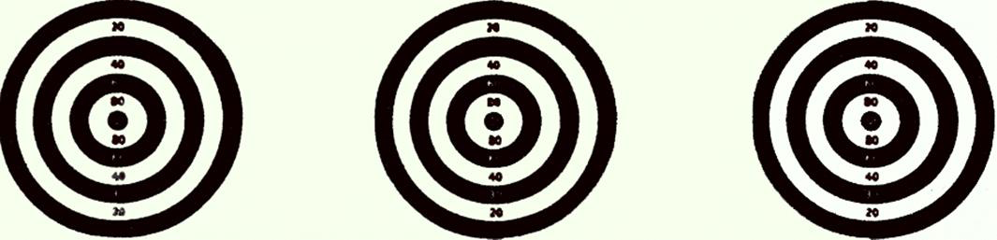

- Accuracy - how close a ________________ comes to an _______________ value
- Precision - how close a ___________ of similar __________________ comes to _______________ (reproducibility)

- EXPERIMENTAL ERROR AND PERCENTAGE ERROR
- The experimental error is calculated by _____________________ the _________________ value from the ___________________ value (E=O-A)

- The ______________________ error is the comparison of the experimental error to the accepted value expressed as a percentage.

- The error may be either positive (the experimental result is too __________________) or negative (the experimental result is too __________________)

- % Error =

- Significant figures

- All the ____________ in a measurement that can be __________________ ____________ plus a _________ digit that must be ___________________

- Finding significant numbers (THE EASY RULES)

  - If there is a decimal place in the number
- Draw an arrow from ___________ to _____________ to find the _________ __________________ digit, then count the ________________________ as significant figures

- 25.0260 =

- 0.00486 =

  - If there is no decimal place in the number
- Draw an arrow from ________________________ to find the _________ __________________ digit, then count the ________________________ as significant figures

- 250260 =

- Representing Data

- Graph –

- Why use graphs?

- Types of graphs

  - Bar graph –

  - Line graph –

  - Circle graph –

