Biology Notes

Parts of a microscope:
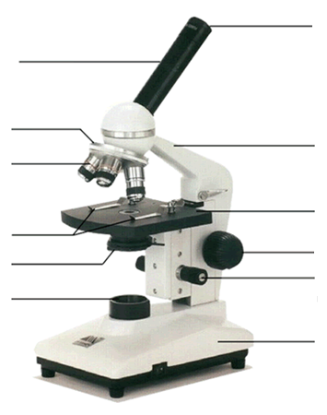

Functions of microscope parts:

- Arm –

- Base –

- Body tube –

- Eyepiece –

- Nosepiece –

- Objective lens –

High power –

Medium power –

Low power –

- Stage –
- Stage clips –

- Diaphragm –

- Course adjustment knob –

- Fine adjustment knob –

- Light source –

Magnification –

Total magnification –

Eyepiece | Objective lens | Total Magnification
10x | 10x
10x | 40x
5x | 10x
5x | 40x
20x | 10x
20x | 40x

Discovery of cells
Robert Hooke –

Anton van Leeuwenhoek –

Matthias Schleiden –

Theodor Schwann –

Rudolf Virchow –

Cell Theory

Theory of Spontaneous Generation –

Advancing the microscope

Light microscopes –

Advantages –

Disadvantages –

Electron microscopes –

Advantages –

Disadvantages –

Transmission electron microscope (TEM) –

Scanning electron microscope (SEM) –

Types of cells:

Prokaryotic –

Eukaryotic –

C ell Parts:

Cell membrane –

Cytoplasm –

Cytoskeleton –

Nucleus –

Nucleolus –

Nuclear envelope -

Organelles –

Mitochondria –

Ribosomes –

Endoplasmic Reticulum (ER) –

Smooth –

Rough –

Golgi Body –

Lysosomes –

Vacuole –

Chloroplasts –

Cell Wall –

Specialized Structures -

Movement through the membrane
Passive Transport –
- Moves from ____________ to ____________

- Diffusion –

- Osmosis –

- Hypotonic
Solute concentration___________
Water concentration___________
Water movement_____________
Effect on cell_________________

- Isotonic
Solute concentration___________
Water concentration___________
Water movement_____________
Effect on cell_________________

- Hypertonic
Solute concentration___________
Water concentration___________
Water movement_____________
Effect on cell_________________

C. Facilitated Diffusion –

Active Transport –

- Moves from ____________ to ___________

- Endocytosis –

- Exocytosis -

