Cell Division

- Cell size is limited by:
- Cell membrane size –

- Small cells have
- Large cells have

- Nuclear control –

- Reasons for cell division
- Growth

- Differentiation –

- Repair
- Regeneration –

- Reproduction
- Asexual reproduction –

- Sexual reproduction –

- The Cell Cycle
- Interphase – _______________________________________ – _______ of total time
- G1 – __________________________________________________________
- S – ______________________ – ________________________________________
- G2 – ________________________ – ____________________________________

- Chromosomes
- Chromatin –

- Sister chromatids –

- Centromere –

- Cell Division
- Mitosis –
- Cytokinesis –

- Stages of Mitosis
- Prophase

- Metaphase

- Anaphase

- Telophase

- Cytokinesis

- Animal cells
- Cleavage furrow –

- Plant cells

Asexual reproduction –

Sexual reproduction –

Meiosis –

Gametes –

Diploid –
Haploid –

All gametes are _____________________

Why can’t gametes divide using Mitosis?

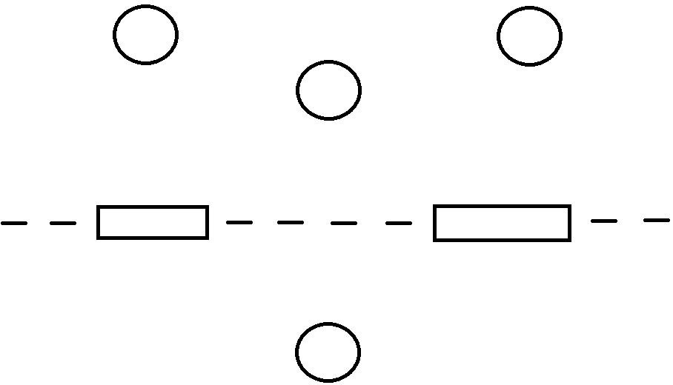

All human cells, except for sex cells, contain ______ chromosomes arranged in _______ pairs

Homologous pairs –

Sex chromosomes –

XX –

XY –

Spermatogenesis –

Oogenesis –

Comparing Mitosis and Meiosis

 | Mitosis | Meiosis
2 divisions
1 division
4 daughter cells produced
2 daughter cells produced
Asexual reproduction
Sexual reproduction
Duplicates chromosomes
Chromosome # stays same
Chromosome # is halved
Daughter cells identical to parent
Daughter cells different from parent

Regulating the Cell Cycle

- Not all cells move through _________________________ at the _______________________
Nerve cells –
Skin cells –
Cells of digestive tract –
Most muscle cells –

- Healing process –

Cyclins –

Internal regulators –

External regulators –

- What happens if cell growth isn’t regulated?

- What causes cells to lose control over growth?

