Cell Division Review Name _______________________________
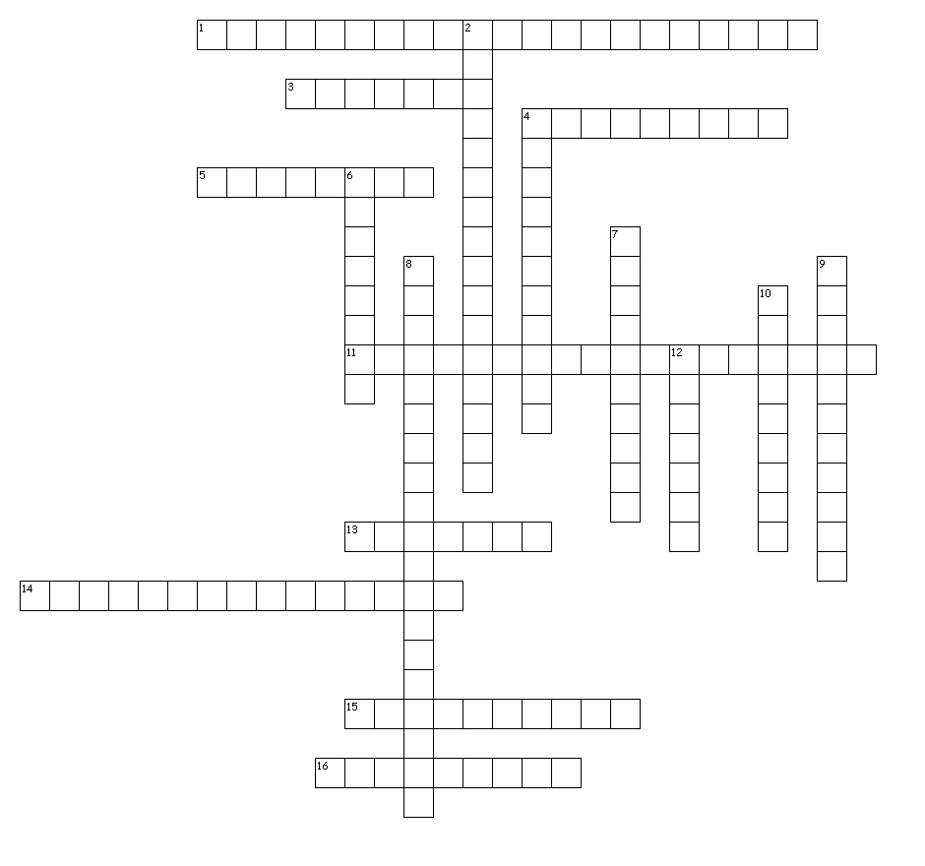
Across
1. Pairs of chromosomes that are the same in size, shape, and pattern
3. Division of the nucleus
4. In which phase do the spindle fibers disappear?
5. In which phase does the cell membrane break down and disappear?
11. Offspring is produced from two parents
13. A cell with one complete set of chromosomes
14. When cells develop into specialized shapes and functions
15. Which phase takes up 90% of the cell cycle?
16. Thin, fibrous form of DNA and proteins that make up a chromosome

Down
2. Two identical structures that result from chromosome replication
4. How many PAIRS of chromosomes are found in human cells?
6. In which phase do the chromosomes separate?
7. The point where sister chromatids are joined together
8. Offspring is produced from only one parent
9. Which phase involves the cell’s membrane pinching to form two separate cells?
10. In which phase do chromosomes line up in the middle of the cell?
12. A cell with two complete sets of chromosomes

- Name and describe the 3 stages of interphase.
_______________________________________________________________________________
_______________________________________________________________________________
_______________________________________________________________________________

- Name and describe two things that limit the size of cells.
_______________________________________________________________________________
_______________________________________________________________________________
_______________________________________________________________________________

- Why is it important for sex cells or gametes to be haploid rather than diploid?
_______________________________________________________________________________
_______________________________________________________________________________
_______________________________________________________________________________

- How does cytokinesis in animal cells differ from cytokinesis in plant cells?
_______________________________________________________________________________
_______________________________________________________________________________
_______________________________________________________________________________

- What is the difference between sister chromatids and homologous pairs?
_______________________________________________________________________________
_______________________________________________________________________________
_______________________________________________________________________________

- How do the chromosomes of an offspring produced by sexual reproduction compare with the chromosomes of its parents?
_______________________________________________________________________________
_______________________________________________________________________________
_______________________________________________________________________________

Fill in the chart with the missing haploid or diploid numbers
Organism | Haploid # | Diploid #
earthworm |  | 36
fern | 505
honeybee |  | 56

