Cell Labeling Name _____________________________

**Animal Cell**

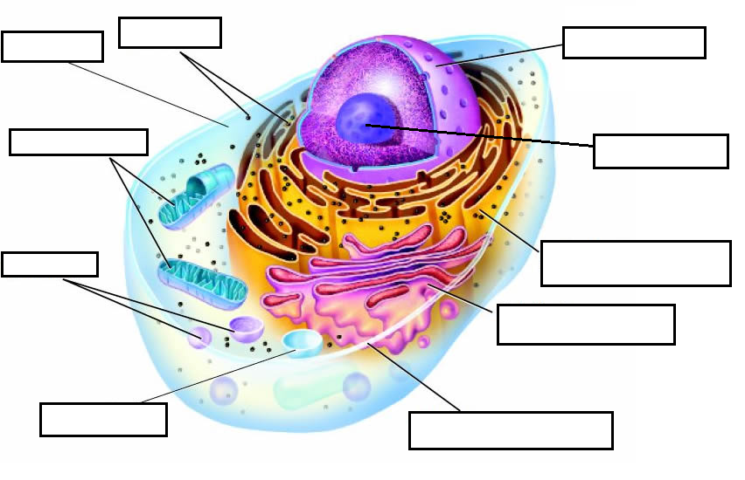

**Plant Cell**

