Chemical Bonding Notes

Elements and the atoms that make them up are most often found in nature as ___________________

Ecology of Atoms describes:

REVIEW

How would you draw an atom?

What is the shell model of the atom?

- Helium | - Oxygen | - Chlorine

Valence Electrons - Electrons in the ____________________________ that are responsible for ____________________________________
Electron Dot Structure - map out only the ___________________________

Electron Dot Structure Tells You 2 Important Things:

- How many ________________________________

- How many ________________________________

Paired Valence Electrons

- ________________________________________________

- ________________________________________________________

Unpaired Valence Electrons

- ________________________________________________

- ________________________________________________________

Ultimate Goal - To Be ____________! Have the entire outer shell __________ and ___________________
Filling the Valence Shell - ________ or ____________________ with other atoms through _______________

Noble Gases - _________________________________, almost never bond with other atoms

Why?

Octet Rule - Atoms tend to ___________, _________, or ___________ electrons to have a _____________ outer valence shell
- Groups 1-3 will ______________________
- Groups 5-7 will ______________________
- Group 4 will ______________________

3 Types of Chemical Bonds

IONIC BONDS

Atoms are _____________ - They have the same number of ____________ and _____________
However…
- To gain _____________, an atom may give up or gain electrons to have a _____________________
Ion - An atom with a ____________ or _____________ charge

  - Cation –

  - Anion –

Examples:

Writing Ions - ______________ to the _________ of the atomic symbol tells the ion’s ____________

Other examples:
- Calcium atom that loses 2 electrons =
- Oxygen atom that gains 2 electrons =

Easy way to know the charge of atoms

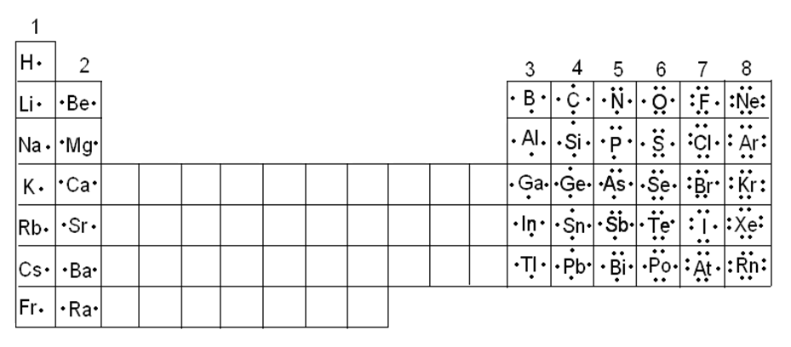
When atoms that tend to lose electrons come in contact with atoms that tend to gain them, the result is an _______________________ and the formation of two _________________________________
ATTRACTION!!! - These two atoms with _____________________ are now ______________ to each other by the electrical ____________
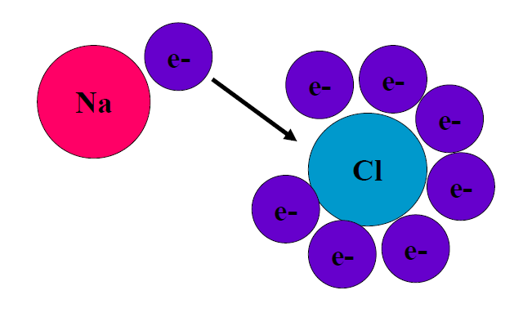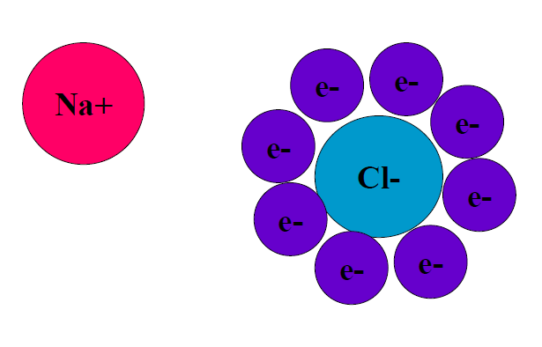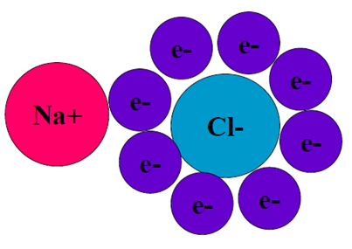
Ionic Bond - The force of attraction between two ____________________________
- Electrons are ______________ and ___________, __________________

Ionic Compounds - Compounds containing ___________
Elements that form ionic compounds - Those found on _____________ sides of the periodic table

Rules for Naming Simple Ions
- CATIONS
  - Borrow names from the ____________
    - EX: K+ =
    - EX: Zn2+=
  - When an ELEMENT forms two or more ions, __________________ indicate the _________
    - EX: Cu+ =
    - EX: Cu2+ =

- ANIONS
  - Name of Anion is also formed form the name of the elements name, but it ends with “_____”!!
    - EX: Cl-
    - EX: O²-
    - EX: P³-

Binary (two) Compounds

- RULE: Place the name of the __________ followed by the name of the ___________
  - EX: NaCl
  - EX: ZnS
  - EX: CuO

For all Ionic Compounds, Positive and Negative Charges ___________________!

- Sodium Chloride:

- Calcium Oxide:

What if the charges differ??
- Calcium²⁺
- Fluoride¹⁻

Ionic Crystals - _____________ of ions grouped together in a ____________________, three-dimensional array
Metallic Bonds

Metals are more willing to _______________ their valence electrons and the bond is ___________

Weak Electrons
- Each metal atom gives up its outer electrons to a ___________________
- The electrons are _____________________ throughout the metal

Metallic Bond - A lattice of ______________________ immersed in a ___________________
- Occurs only between _______________________

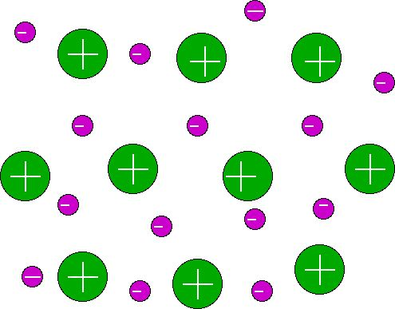

How does this metallic bond explain the properties of metals?

- Conduct electricity and heat?

- Shiny?

- Malleable?

Metallic Bonds can hold together two or more of the ________________ or _______________________
Alloys – __________________ with one or more _______________________

Examples:

COVALENT BONDS

Two atoms can be held together by their _________________________ for the electrons they ___________
Covalent Bond - Mutual attraction for ___________ electrons
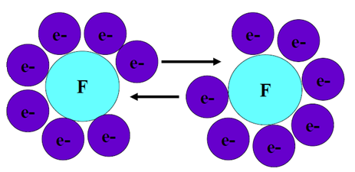
Molecule - Two or more atoms that ___________________________

Writing Electron Dot Structures for Covalent Compounds

- A ________________ is used to represent the ______________________________ (1 from each atom)

Elements that form Ionic Compounds
- Those found _______________________ on the periodic table, mostly between ________________

A covalent bond is made up of ____________________

- The _____________________________ an atom can form is equal to the _______________________ needed to ______ its valence shell

Hydrogen – needs only _____ additional electron so it forms only _____ covalent bond

Oxygen – needs _____ additional electrons. Forms _____ covalent bonds with Hydrogen to make the molecule H₂O or water

Nitrogen – needs _____ additional electrons. Forms _____ covalent bonds with Hydrogen to make NH₃ or ammonia

Carbon – needs _____ additional electrons. Forms _____ covalent bonds with Hydrogen to make CH₄ or methane

It is possible to share _________________ electrons in a covalent bond

Double bond – shares _____ electrons

Example –

Triple bond – shares _____ electrons

Example -

Bond Strength - Single bonds are __________ and ___________________, while triple bonds are ___________ and ________________________
Draw the Dot Structure for each molecule

PH₃ H₂S CCl₄

Rules for Naming Covalent Compounds

- The ________ element in the formula is ______________ and keeps its ___________________

- The ________ element changes its suffix to “______”

- __________ are used to tell _______________ of each atom is used in the compound

# of atoms | 1 | 2 | 3 | 4 | 5 | 6 | 7 | 8 | 9 | 10
Prefix

- The first element ______________ the mono- suffix
If the two atoms in a covalent bond are ______________, the electrons are shared ___________

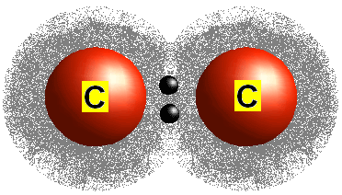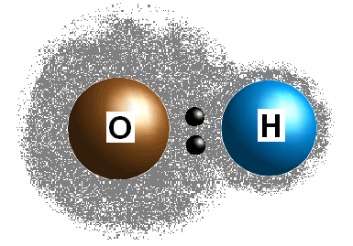

If the two atoms in a covalent bond are ___________________, the electrons are shared ______________

Dipole – ________________ of charge

Since the Oxygen has the electrons around it for most of the time, it has a _______________________ and Hydrogen has a ______________________

Electronegativity – atoms ability to _______________________________ in a chemical bond

The __________ the electronegativity, the _____________________ to pull in electrons

___________ in elements on the _______________ of the periodic table, and ___________ for elements on the ________________. _______________ are excluded.

Nonpolar bond –

- Dipoles __________________ when atoms have the ___________ electronegativity

Polar bond –

- Dipoles ________ when atoms have ____________ electronegativity

How polar a bond is depends on the _______________________________________ between atoms

- The _____________ the difference, the ____________________ the bond

Intermolecular Forces

Bonds between atoms are __________, but attractive forces between molecules are ________

Intermolecular forces –

Types of Intermolecular Forces

- Ion-Dipole Attraction

  - Between ___________ and the _________________________________

Example: ______________ of __________ salts in ___________ solution

- Dipole-Dipole Attraction

  - Between _____________________________

Hydrogen Bond – between molecules that have _____ bonded to a highly electronegative atom (________)

Example: ________________________because water molecules are so _____________ to themselves

- Induced Dipole-Dipole Attraction

- Between a __________ and _____________________ molecule

Induced dipole - ________________ uneven distribution of electrons

Example: ____________ binding to _________ in Hemoglobin
Example:

Adhesive and Cohesive Forces

Cohesive forces - Forces of attraction between ____________________________

Water - Pull water into _______________ drops

Adhesive forces - Forces of attraction between ____________________________

Water - _________ water to surfaces

________________ is determined by ____________ of cohesive and adhesive forces

- If ____________ force is stronger…Water drop will be ____________

- If ____________ force is stronger…Water drop will be ____________

Meniscus - ____________ of a liquid's ____________ within a container

- Concaves Up the Sides - When the _______________ force of the liquid to the wall is _____________ than the cohesive force of the liquid, the liquid is more _______________________________ than its neighbors

- Concaves Down the Sides - When the ________________ force of the liquid is ______________ than the adhesive force of the liquid to the wall, the liquid concaves down in order to ___________________________with the surface of the wall

