Ecology Review Worksheet Name _________________________________

Write out the definitions for the following terms:
- Ecology –
- Biotic –
- Abiotic –
- Omnivore –
- Carnivore –
- Herbivore –
- Carrying capacity –
- Food chain –
- Climate –
- Limiting factor –
- Precipitation –

Fill out the main characteristics (climate, plants and animals) for each of the biomes

Desert
Grassland
Chaparral
Tropical Rainforest
Tundra
Temperate Forest
Taiga
Coastal Wetland
Flowing Water
Standing Water
Marine Biome
Estuary

Inland Wetland

Write out the 5 levels of organization in order from smallest to largest

_______________ → _______________ → _______________ → _______________ → _______________

Name 2 examples of density-dependent factors:
- __________________________________________________________________
- __________________________________________________________________

Name 2 examples of density-independent factors:
- __________________________________________________________________
- __________________________________________________________________
Using the food web, answer the questions below:
- Label each organism (some may have more than one label) as:  P = Producer  1 = 1st order consumer  2 = 2nd order consumer  3 = 3rd order consumer  - Hawk = ________________________  - Snake = ________________________  - Fox = __________________________  - Rabbit = _______________________  - Squirrel = ______________________  - Frog = _________________________  - Butterfly = _____________________  - Fruit tree = ____________________  - Worm = _______________________  - Bird = _________________________ | 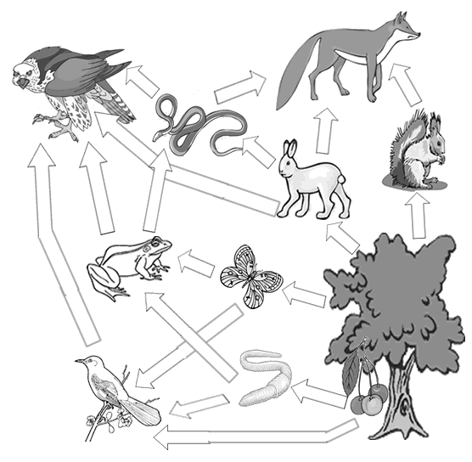
- Name the animals that eat the rabbit: ________________________________________________________________
- Name the animals that the frog eats: _________________________________________________________________

Shade In and Label the 3 different climate zones on the map:

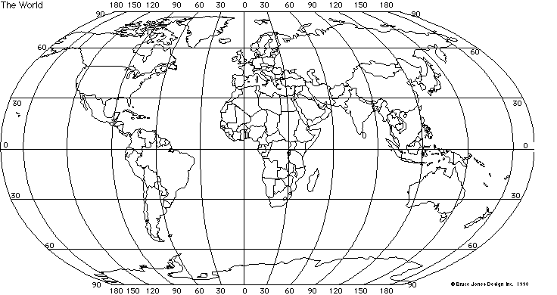

Label each example or statement as C = Commensalism, P = Parasitism, or M = Mutualism
_____a. One benefits while the other is harmed
_____b. Both benefit
_____c. One benefits while the other is unaffected
_____d. The cattlecrane eat the bugs that are stirred up by the cows walking through the mud.
_____e. The oxpecker birds eat the blood sucking parasites found on the skin of the rhinos.
_____f. Mosquitoes suck the blood of humans.

Draw a graph that shows exponential growth:

