Electrolysis of Water Experiment Name ____________________________

Energy is stored in the bonds of molecules. When these bonds split apart, the energy released can be used to do work. Breaking apart liquid water molecules into hydrogen and oxygen gas creates an enormous amount of energy, which can be turned into useful electricity to power our homes and cars.
To break these bonds, some amount of energy is required to get the atoms in water molecules active enough to break apart from each other. At home, we can supply this energy with a battery. All batteries have two terminals, or ends: a positive terminal and a negative terminal. The water then connects these terminals, so energy can flow between them. As the electricity passes through the water, it splits the water!
Pure water itself is not a good conductor of electricity, so for this experiment baking soda will be added to make the solution an electrolyte. An electrolyte is a part of a solution that can be broken up by electrolysis. Electro refers to energy and electricity and -lysis refers to splitting apart. Electrolytes are important both in batteries and in our bodies!

Problem
During the electrolysis of water, which electrolyte conducts electricity the best?

Materials  - Distilled water  - Tap water  - 2 silver-colored thumb tacks  - 9V battery  - Small, clear plastic cup  - 2 test tubes  - Baking soda  - Table salt  - Lemon juice  - Dishwashing detergent | 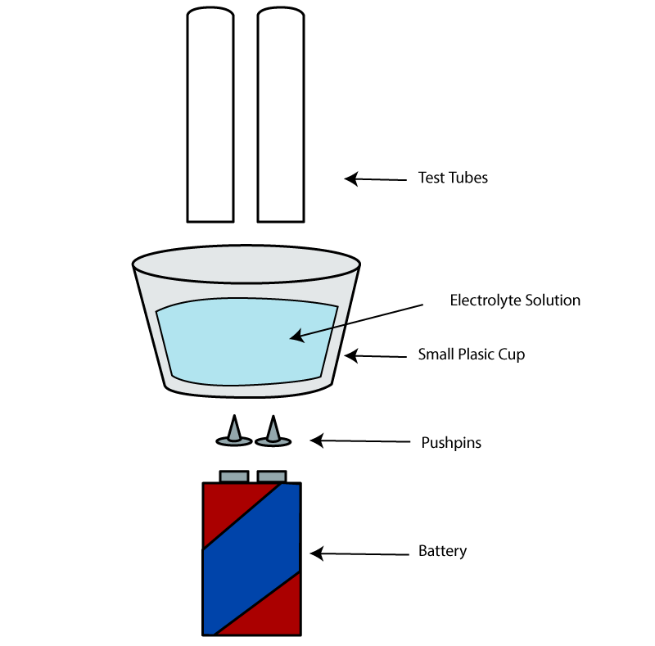

Procedure

- Insert the thumb tacks into the bottom of the plastic container so that the points push up into the container. Space them so that they’re the same distance apart as the two terminals of the 9V battery. Be careful not to prick yourself!

- Slowly fill the container with distilled water. If the tacks move, go ahead and use this opportunity to fix them before you proceed.

- Place the plastic container with the thumb tacks over the terminals of the battery. If the cup is too large to balance on the battery, find something to stack it on: between two books, a stack of post-its, etc.

- Will distilled water conduct electricity on its own? Try it! What did you observe? ______________________________________________________________________________________
- Add a little baking soda to the water and mix well.

- Hold two test tubes above each push pin to collect the gas being formed. Record your observations. What happens? ______________________________________________________________________________

- Does one tube have more gas than the other? _________________________________________________

- What gases are forming?__________________________________________________________________

- Discard the solution, and repeat the procedure with a different combination:
  - Distilled water and lemon juice
  - Observations? __________________________________________________________________

  - Distilled water and table salt
  - Observations? __________________________________________________________________

  - Distilled water and dish detergent
  - Observations? __________________________________________________________________

  - Tap water (Does tap water work? If so, why?)
  - Observations? __________________________________________________________________

Results

    - Which solution released more gas bubbles? _________________________________________________

    - What is your hypothesis for this result? _____________________________________________________
__________________________________________________________________________________________________________________________________________________________________________

    - Which solution released the least bubbles? _________________________________________________

    - What is your hypothesis for this result? _____________________________________________________
__________________________________________________________________________________________________________________________________________________________________________

