Energy Review Name _________________________________
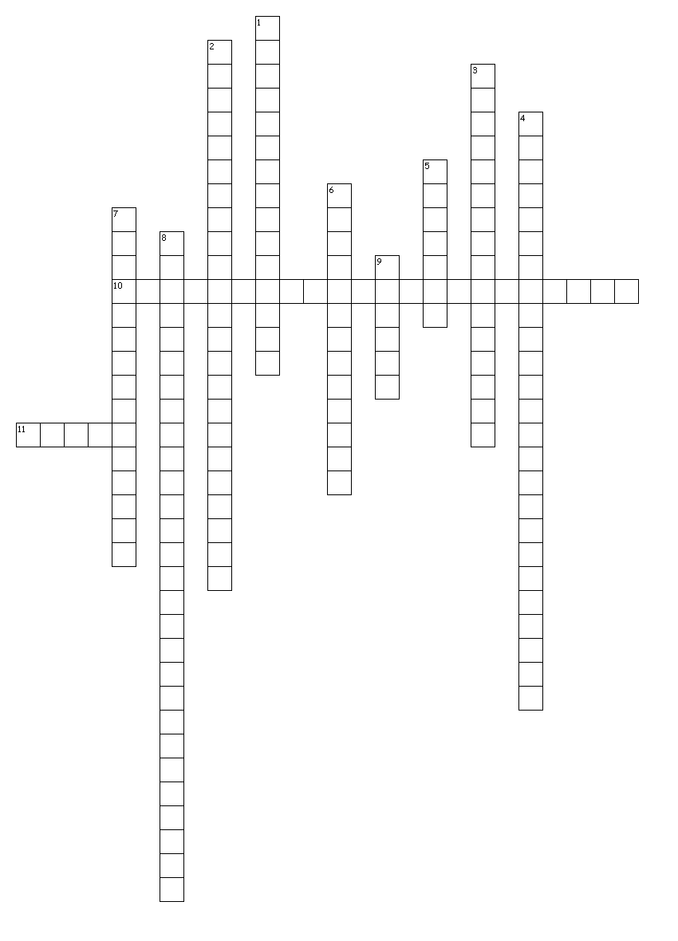
Across
10. Stored energy in something that compresses or stretches
11. The SI unit for measuring energy
Down
1. Kinetic energy depends on what two things?
2. Energy stored in chemical bonds
3. Potential energy + Kinetic energy
4. States that energy cannot be created or destroyed
5. SI unit for the amount of energy in food
6. Energy in motion
7. Stored energy
8. Stored energy due to its position above the Earth
9. The ability to cause change

Questions
- Why do the brake pads on your bicycle become warm as you ride down a long hill while applying your brakes?

- Suppose you drop a tennis ball out of a second-floor window. The first bounce will be the highest. Each bounce after that will be lower until the ball stops bouncing. Write a description of the energy conversions that take place. Starting with dropping the ball. Accompany your description with an appropriate illustration.

- Your body used energy as you walked into your school today. Where did this energy come from? Write a paragraph describing where you acquired the energy. Trace it back through as many transformations as you can.

- In the following situations, energy is changed from one form to another. Study each situation and identify the energy transformations: (select 2 to answer. You do not have to answer the other 2)
  - A chandelier brightens a ballroom after a waiter moves a switch.
  - A jet plane rapidly accelerates on the runway.
  - A walnut falls to the ground from a lofty branch on a walnut tree.
  - A base runner slides safely into third base.

Kinetic Energy Use this equation: KE = ½ mv²
- What is the kinetic energy of a child on a swing with a mass of 30 kg and a speed of 3 m/s?

- What is the mass of an object with a speed of 30 m/s and a kinetic energy of 400 J?

Gravitational Potential Energy Use this equation: GPE = m x 9.8 m/s² x h
- What is the GPE of a bowling ball with a mass of 1.5 kg and held 2 meters above the ground?

- A ball with a mass of 0.3 kg and a GPE of 30 J is how far above the ground?

