Fluids Experiment: Show Relationship Between Water Pressure and Depth
by Ron Kurtus (revised 19 March 2009)
You may have noticed when you swim underwater, that the deeper you go the greater the pressure on your ears. You've also probably seen how deep-sea divers must protect themselves against the water pressure at greater depths. This may get you curious as to how to verify the relationship between water pressure and depth.
Finding the relationship between water pressure and depth can be an idea for a science project in the area of physical science. The biggest problem is in measuring water pressure. A clever way to demonstrate increasing water pressure is by showing how far it will squirt from an opening.
Questions you may have include:
- What is the purpose of the experiment?
- What research must be done?
- What is the experiment?
This lesson will answer those questions.

Purpose of experiment
The purpose of the experiment is to demonstrate how water pressure increases with depth. You can also make some rough measurements to show an approximate relationship between depth and water pressure.

Research
It is good to research the physical laws with respect to what pressure is, as well as the concept of increasing pressure in a fluid due to the weight of the fluid. One other research item concerns the relationship between water pressure and how far a stream of water would squirt.
Pressure is force per unit area. At any point in a fluid, the pressure is the same in all directions. Water pressure at a given depth in an open container, such as a swimming pool, is shown by the equation: P = gh, where
- P is the water pressure
- g is the acceleration of gravity
- h is the depth of the water at that point
- gh is g times h

Experiment
You know that as you turn up the pressure in a hose, the water squirts out further. So, there is a relationship between pressure and how far the water squirts.
If you had a container with a hole in it, and if it is true that pressure increases with depth, then the water should squirt out further the higher the water level. You could show this by having one hole and measuring how far the water squirts as you change the depth of the water in the container, or you could put several holes at different heights and show how the water squirting varies.
Note: If you use several holes, they all should be the same size. As you will see in the next experiment the hole size is another variable. You don't want to mix variables in an experiment.

Materials
- Large tin can or plastic milk bottle.
- Hammer and nail
- Ruler
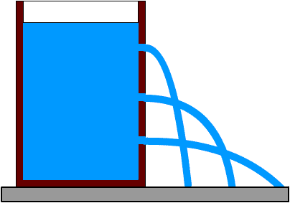
Water squirts further at greater depths

Steps
- Punch holes in side of the container at one inch intervals.
- Fill the container with water.
- Measure the distance from the container that the water squirts out of each hole.
- Plot a graph of depth (distance of hole from top of water level) versus distance water squirts from can.

Keep records
If this is going to be an experiment for a science fair, you will need to record your activities in a log book.

Draw conclusions
This experiment should verify that since the water squirts out further with increasing depth, that the water pressure increases with depth.

Write report
Write up a report to summarize your results and your proposed solution to the problem.

Summary
Since you noticed that the deeper you go in water the greater the pressure on your ears, you can perform an experiment to verify the relationship between water pressure and depth. The biggest problem is in measuring water pressure. A clever way to demonstrate increasing water pressure is by showing how far it will squirt from an opening.

