Food Web Worksheet Name _________________________________
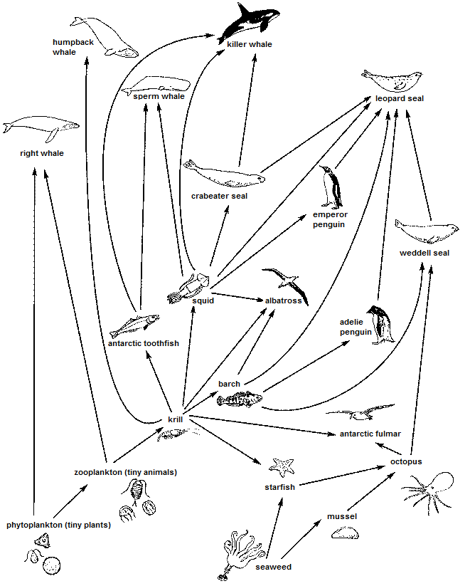
- Name all the producers
- b.

- Name all the animals that eat krill
- b. c. d. e. f. g.

- What animals are eaten by the killer whale?
- b. c.

- Name all the 1st order consumers
- b. c. d.

- Name all the 2nd order consumers
- b. c.

- Name all the 3rd order consumers
- b. c. d. e. f. g.
h.
- Construct a single food chain based on the descriptions below:
- Algae are eaten by snails which are eaten by crayfish

- A cougar eats a squirrel which eats a grasshopper which eats a dandelion

- On a blank piece of paper draw out the following food chains to create a well designed food web. Staple to this page.
- Conifer needles → grouse → hawk
- Conifer seeds → field mouse → cougar
- Dandelions → grasshopper → squirrel
- Berries from shrubs → shrew → hawk
- Dandelions → grasshopper → spider → field mouse
- Grasses/thistles → grasshopper → spider → squirrel
- Grasses/thistles → deer → cougar
- Conifer seeds → squirrel → cougar
- Grasses/thistles → grasshopper → squirrel → hawk
- Conifer seeds → grouse → hawk
- Dandelions → deer → cougar
- Berries from shrubs → grouse → hawk
- Conifer seeds → squirrel → hawk
- Conifer seeds → field mouse → hawk
- Berries from shrubs → shrew → cougar
- Berries from shrubs → deer → cougar
- Dandelions → grasshopper → spider → shrew
- Grasses/thistles → grasshoppers → grouse
- Berries from shrubs → squirrel → cougar
- Berries from shrubs → field mouse → hawk

- Use your diagram/drawing of the food web from above to answer the following questions
- Name everything the squirrel eats.

- Grasses/thistles are eaten by what animals?

- The field mouse is food for which animals?

- Which animals are not eaten by anything else in this food web?

- Name the 2 strictly herbivores from the diagram

- Name the 4 omnivores from the diagram

- Name the 3 strictly carnivores from the diagram

