Matter and Chemical Change Lab Name ___________________________________

- Video clip 1 – write down one evidence that a chemical change occurred
- _________________________________________________

- Video clip 2 – write down one evidence that a chemical change occurred
- _________________________________________________

- From the counter, grab a zip lock bag, a clear pill container, and a piece of steel wool.
  - Carefully fill pill container about ½ full with hydrogen peroxide on counter
  - Place the pill container carefully inside the bag
  - Place the small piece of steel wool in the bag also without letting it touch the hydrogen peroxide in the pill bottle
  - Squeeze out as much air from the bag as possible and then carefully zip up the bag
  - Tip over the pill bottle of hydrogen peroxide so it comes in contact with the steel wool
Write down two evidences that a chemical change occurred
- ________________________________________________
- ________________________________________________

- Identify each side of the equation as the products or the reactants

- Hydrogen + Oxygen Water

____________________ ____________________

- Mercury Oxide Liquid Mercury + Oxygen

____________________ ____________________

- Sodium Chloride Sodium + Chlorine

____________________ ____________________

5. Fill out the table with the correct phase states and processes
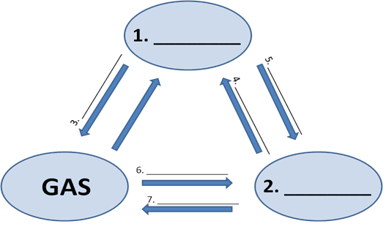

- Consider the following decomposition reaction:
2 H2O2 2 H2O + O2
If 72 grams of water and 64 grams of oxygen are produced, what mass of H2O2 decomposed?

- Consider the following chemical reaction:
2 NaCl + Ca(OH)2 CaCl2 +2 NaOH
If the mass of NaCl reacted is 191 grams and calcium hydroxide 74 grams and 80 grams of sodium hydroxide is produced, what mass of calcium chloride is produced?

