Matter

Matter –

Substance –

- Example –

- Not substances –

States of Matter

Solid –

Liquid –

Gas –

Gas vs. Vapor

Gas –

Vapor –

Properties –

Physical Property – characteristic that can be observed or measured __________________
changing the ______________________

- Extensive property - ___________________________ on the amount of substance

- Examples:

- Intensive property - _______________________________ on the amount of substance

- Examples:

Chemical Properties – a substance’s ability to _____________ with or ______________ into
something ___________

- Example:

External Conditions – changing states of matter can _____________ physical and chemical
properties

- Example:

Changes in Matter

Physical Change –

Examples:

Change of State – change from one ______________________________ to ____________________

- To change state, you must ____________ or _______________ energy

Adding Energy

Melting – change from a _______________ to a _____________________

- Melting point –

Water :

Vaporization – change from a _________________ to a ___________________

- Evaporation – when vaporization occurs only at the ________________ of a liquid

- Boiling point –

Water:

Sublimation – change from a _________________ to a ___________________

- Examples:

Removing Energy

Freezing – change from a ___________________ to a ______________________

- Freezing point –

Water :

Condensation – change from a __________________ to a _____________________

- Condensation point –

Water:

Deposition – change from a ___________________ to a ______________________

- Examples:

Chemical Change –

Examples:

Starting substances –

New substance –

Evidence of a Chemical Change –

Color –

Odor –

Produce heat/light –

Exothermic reaction –

Endothermic reaction –

Produce gas –

Produce solid –

Physical Change vs. Chemical Change –

Can reverse –

Can’t reverse –

Law of conservation of mass – Mass is neither __________________ nor ____________________ during a chemical reaction – it is ______________________

Mass of reactants =

Examples: 22.99 g + 35.45 g = _______________________
Sodium Chlorine Sodium Chloride

12.2 g + ____________ = 78.9 g
X Y XY

Mixtures

Mixture – a combination of _______________________ substances that _____________ chemically combine

- Each substance keeps its _______________________

Types of mixtures

Heterogeneous mixtures –

Examples:

Homogeneous mixtures –

Examples:

Solutions –

- Solute –

- Solvent –

Gas-gas –

Gas-liquid –

Liquid-gas –

Liquid-liquid –

Solid-liquid –

Solid-solid –

Alloys –

Example:

Separating Mixtures

Mixtures are _________________ combined – processes to separate them are _____________ processes

Common Separation Methods

Filtration –

- Examples:

Distillation –

- Substance with the ______________ boiling point will __________________ first
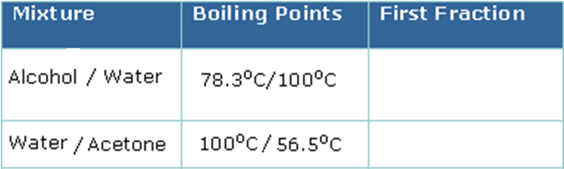

Crystallization –

Chromatography –

- Examples:

