Using a Dichotomous Key Name ________________________________

Help! Scientists have discovered quite a few new creatures on planet Pamishan. They need your help to identify and classify them. Use the dichotomous key on the next page to identify these creatures.

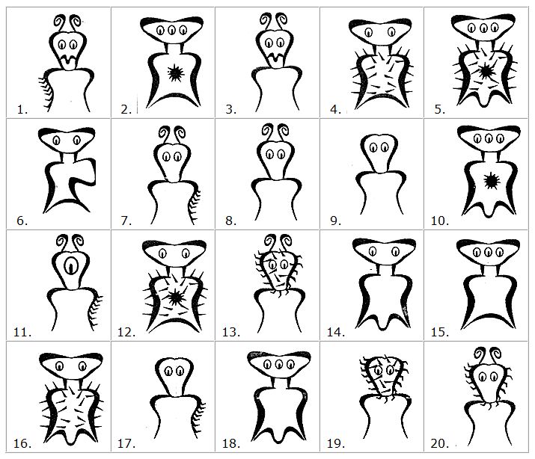

A Key to New Pamishan Creatures
1. | a. The creature has a large wide head............................go to 2
 | b. The creature has a small narrow head..........................go to 11
2. | a. It has 3 eyes ................................................go to 3
 | b. It has 2 eyes ................................................go to 7
3. | a. There is a star in the middle of its chest....................go to 4
 | b. There is no star in the middle of its chest ..................go to 6
4. | a. The creature has hair spikes ...........................Broadus hairus
 | b. The creature has no hair spikes.........................go to 5
5. | a. The bottom of the creature is arch-shaped ..............Broadus archus
 | b. The bottom of the creature is M-shaped .................Broadus emmus
6. | a. The creature has an arch-shaped bottom .................Broadus plainus
 | b. The creature has an M-shaped bottom.....................Broadus tritops
7. | a. The creature has hairy spikes ..........................go to 8
 | b. The creature has no spikes..............................go to 10
8. | a. There is a star in the middle of its body ..............Broadus hairystarus
 | b. The is no star in the middle of its body ...............go to 9
9. | a. The creature has an arch shaped bottom .................Broadus hairyemmus
 | b. The creature has an M shaped bottum ....................Broadus kiferus
10. | a. The body is symmetrical ................................Broadus walter
 | b. The body is not symmetrical.............................Broadus anderson
11. | a. The creatrue has no antennae ...........................go to 12
 | b. The creature has antennae ..............................go to 14
12. | a. There are spikes on the face ...........................Narrowus wolfus
 | b. There are no spikes on the face ........................go to 13
13. | a. The creature has no spike anywhere .....................Narrowus blankus
 | b. There are spikes on the right leg ......................Narrowus starboardus
14. | a. The creature has 2 eyes.................................go to 15
 | b. The creature has 1 eye..................................Narrowus Cyclops
15. | a. The creature has a mouth................................go to 16
 | b. The creature has no mouth...............................go to 17
16. | a. There are spikes on the left leg .......................Narrowus portus
 | b. There are no spikes at all .............................Narrowus plainus
17. | a. The creature has spikes ................................go to 18
 | b. The creature has no spikes .............................Narrowus georginia
18. | a. There are spikes on the head ...........................go to 19
 | b. There are spikes on the right leg.......................Narrowus montanian
19. | a. There are spikes covering the face .....................Narrowus beardus
 | b. There are spikes only on the outside edge of head ......Narrowus fuzzus

