Phylogenetic Trees Name______________________________
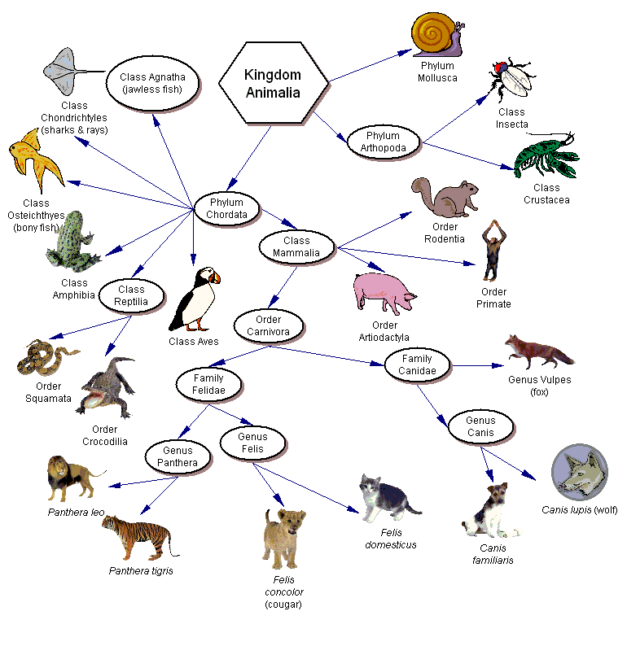
Answer true or false to the following statements.
1. ______ Dogs belong to the order Felidae.
2. ______ A fox belongs to the phylum Arthropoda.
3. ______ Snakes belong to the phylum Reptilia.
4. ______ Lions belong to the class Mammalia
5. ______ All arthropods belong to the Class Insecta
6. ______ All rodents belong to the phylum Chordata.
7. ______ All amphibians belong to the class Reptilia.
8. _______ All primates are mammals.
9. _______ The class Mammalia includes dogs, cats and rats.
10. ______ A lion belongs to the genus Felis.
11. ______ All mammals are primates.
12. ______ Insects and lobsters are arthropods.
In each set, circle the pair that is most closely related.
13. snakes & crocodiles | snakes & frogs
14. rats & cats | cats & dogs
15. insects & lobsters | insects & birds
16. lions & tigers | lions & cougars
17. foxes & rats | foxes & dogs
18. cats & dogs | cats & lions
17. List (use species name) all the animals pictured that belong in the Felidae family.

18. List all the animals pictured that belong to the Carnivora order.

Analyze the Cladogram
Examine the sample cladogram, each letter on the diagram points to a derived character, or something different (or newer) than what was seen in previous groups. Match the letter to its character. Note: this cladogram was created for simplicity and understanding, it does not represent the established phylogeny for insects and their relatives.
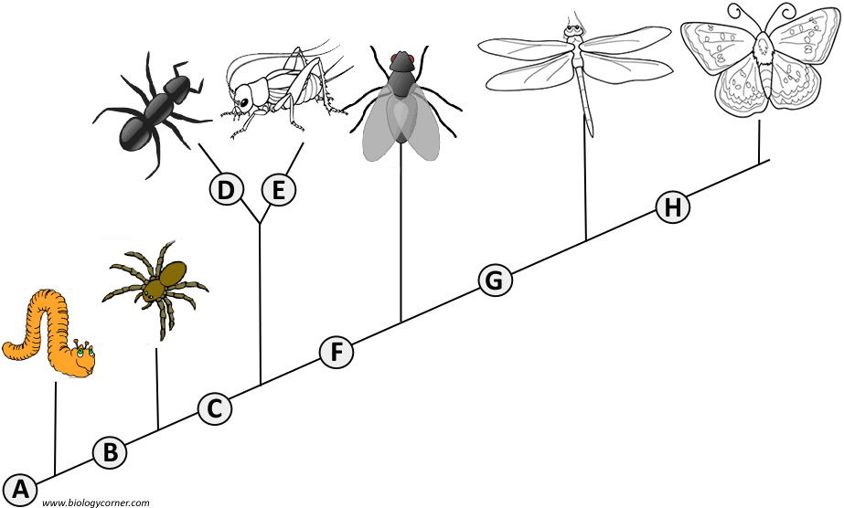
1. ______ Wings
2. ______ 6 Legs
3. ______ Segmented Body
4. ______ Double set of wings
5. ______ Jumping Legs
6. ______ Crushing mouthparts
7. ______ Legs
8. ______ Curly Antennae

