Processes of Science

Scientific Method - ______________ used by scientists to __________________________ and _______________________

- Ask a Question - helps focus the ________________ of an investigation

- Observation - ______________________________ with the senses

- Form a Hypothesis - A ____________________________ to your question (_______________________)

- A good hypothesis is ______________!
- Prediction - ____________ hypothesis in an __________statement to help __________ the test

- Test Hypothesis - Find out if your hypothesis is __________________________

- Controlled Experiments
  - Compares a __________ group to an _________________ group
  - Changes _________________ variable at a time

- Data - _____________________ acquired through observation or experimentation

- Analyze results - organize information using calculations, ____________, _____________…

- Draw Conclusions
- _______________ if your hypothesis is supported
- Perform __________________________

- Communicate Results
- Lets others ____________ your work
- Brings up other _________________

Scientific models – a __________________ of something familiar to describe something ___________________

- Limits: _____________________________________________

- Physical Models – shows you what it ________________________
  - Example:

- Mathematical Models – uses ___________________ and data
  - Example:

- Conceptual Models – systems of ____________ or ____________________ to explain something
  - Example:

- Models explain things that are too _____________, too _______________, or just impossible to see

Theory – an ___________________ of many hypothesizes and observations. Explain ________________________

Law – a _____________________ of many hypothesizes and observations. Explain ______________________

Analyzing Data
Units – Language of Science
- SI system (____________________) – standard unit of measurement

- There is only _____ base unit for each thing measured
- Length =
- Weight =
- Volume =

- How big are they?
- Meter - | 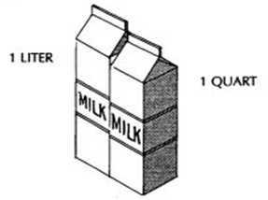
- Liter -
- Gram -
- Measured in multiples of ___________

- Prefix -

- 6 Common Prefixes

Prefix | Symbol | Number
Base Units (meter, liter, gram)

- Decimal Moving

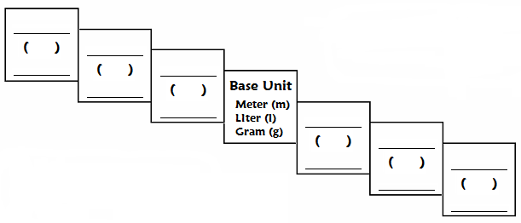
Conversion steps:
- Find your ___________ point and ___________ point
- Count the ____________ of _________ you take to get from your starting point to your ending point.
- The decimal is moved ____ place for every ______ you take
- Move the decimal to the ________ if going up the stairs
- Move the decimal to the ________ if going down the stairs

- Meter –
- Common measurements
  - 1mm =
  - 1 cm =
  - 1 dm =
  - 1m =
  - 1km =

- Area - the number of ________________ that fit in a 2-D object
a.

- Liter –
- Common measurements
  - 5mL =
  - 250mL =

- Volume - the number of ________________ that fit in a 3-D object

- Gram –
- Common measurements
  - 1g =
  - 1kg =

- Celsius –
- Common measurements
- freezing point of water = _______  - Boiling point of water = _______  - Body temperature = _______  - Remembering a few temperatures in Celsius:  __________ is _______,  __________ is ________,  ______ is ___________,  ________ is _______. | ˚C ˚F

Density - measures the amount of ________ in a given unit of ________________
“I’m your density” | Equation:

- Water has a density of ____________
  - If an object is more dense than water, it will ____________. If it is less dense than water, it will ______________.

Uncertainty in Data
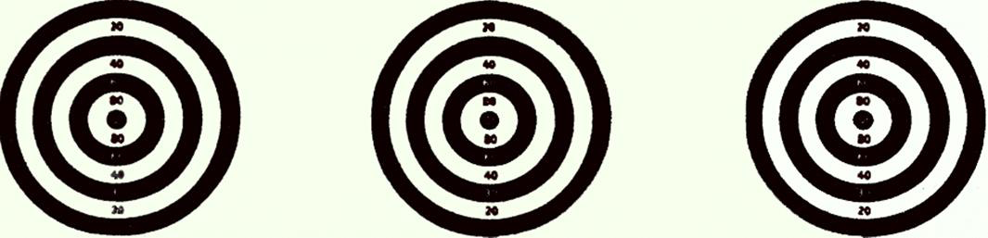

- Accuracy - how close a ________________ comes to an _______________ value
- Precision - how close a ___________ of similar __________________ comes to _______________ (reproducibility)

Representing Data
- Graph –

- Why use graphs?

- Types of graphs

  - Bar graph –

  - Line graph –

  - Circle graph –

