Properties of Matter Review Name ______________________________________

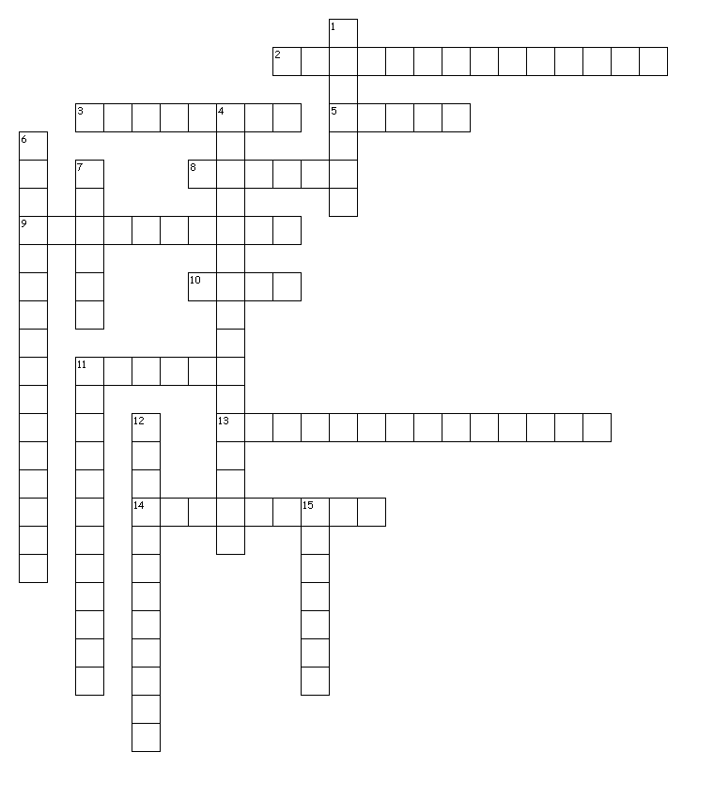
Across
2. Changing into a new substance with new and different properties
3. The curved surface of a liquid
5. The physical form something is in such as solid, liquid, or gas
8. The measure of gravitational force exerted on an object
9. Ability to dissolve in another substance
10. The amount of matter in an object
11. Anything that has mass and takes up space
13. Changing matter from one form to another without changing its identity
14. Ability to be drawn into wires

Down
1. Amount of matter in a given volume
4. The ability of an object to change into new matter with new properties
6. Characteristic such as color, odor, mass, and volume
7. The amount of space taken up by an object
11. Ability to be rolled or pounded into sheets
12. Rate at which something transfers heat
15. The tendency of an object to resist a change in motion

- What are the differences between Physical Change and Chemical Change?

________________________________________________________________________________________________________________________________________________________________________________________________________________________________________________________________________________________________________________________________________________________________________________________

- What are 2 examples of chemical properties?

- What is the metric unit used to measure mass? __________________________________

- How do you measure the volume of a regular shaped object?

- How do you measure the volume of an irregular shaped object?

- What are 5 examples of physical properties?

- What is the equation to find density? _____________________________

- An object has a mass of 20 g and takes up 10 mL of space. What is the density of the object?

- What is the volume of the box? | 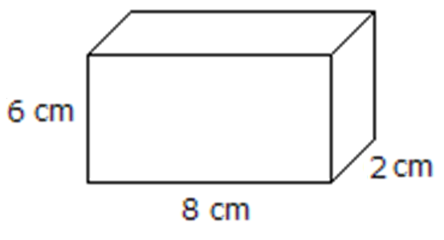
- Write out the following measurements in mL.
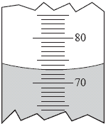 = _____________ 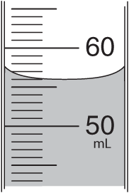 = ______________

- Explain the differences between mass and weight

________________________________________________________________________________________________________________________________________________________________________________________________________________________________________________________________________________________________________________________________________________________________________________________

- Tell whether each example shows a physical or a chemical change. Write P for physical and C for chemical.

_____ Breaking a pencil _____ Crumpling up tin foil _____ Carving wood
_____ Moldy cheese _____ Fireworks _____ Baking soda and vinegar
_____ Water freezing _____ Statue of Liberty _____ Rusty nail
_____ Sour milk _____ Recycling old cans into new ones _____ Not really reversible
_____ Tearing paper _____ Mashing a banana _____ Are reversible

