Protista Name ____________________________________

- Why is kingdom Protista often referred to as a “junkyard”?

- What is the ONE trait that all protists share?

- Name, describe, and give an example of the four groups of Protozoans.

- Draw an ameba and label it including: endoplasm, ectoplasm, cell membrane, nucleus, pseudopod, food vacuole, contractile vacuole

- Do amebas have cell walls? Explain.

- How are cilia different than flagella?

- What is a pellicle?

- What is the purpose of the contractile vacuole?

- Why are sporozoans always parasites but ciliates rarely ever are?

- Label the Asasia below including: pellicle, flagellum, cytoplasm, nucleus, contractile vacuole, food vacuole, gullet, eyespot, and reservoir.

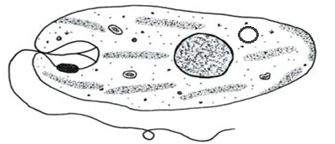

- Draw a star showing which end of the Astasia above is the front end.

- What causes “red tide”?

- Why is red tide a problem?

- Where would you find green algae?

- Where would you find brown algae?

- Where would you find red algae?

- Kelp and seaweed are which type of algae?

- What’s the difference between plasmodial slime molds and cellular slime molds?

- Why are water molds important?

