5 Senses

- Sight
- The body’s ______________ sense

- _________ of the information we take in comes from our ___________

- The Eye

- About the size of a ___________________ and sits in the _________________ of the skull

- Sclera – the _________________ of the eye

- Cornea – ___________ at front of eyeball, starts to _________ light

- Iris – __________ part of eye, ___________ amount of _________ entering the eye

- Pupil - ___________ in the iris

- Smaller –
- Bigger –

- Lens – _______________, ______________ light on the ______________

- Retina – ___________ layer of eye, contains ___________________

- Optic Nerve – Carries ______________ of sight from the eye to the ____________

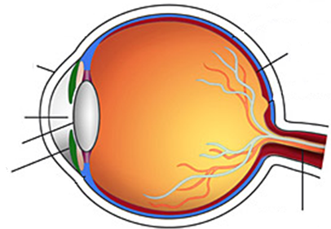

- How we see

- Light enters eye through _____________

- It passes through the _______________

- Makes an ___________________ image on the __________________ at the back of the eye

- Cells send _________________ down the __________________________ to the _________

- Seeing in color – ______________________ shine on an object, but we only see the ________________ colors. The others are ___________________

- Photoreceptors-

- Rods – see _______________________________

- Cones – see ________________

- Blurry Vision – eyeball is the wrong _____________, can’t focus light on the ______________

- Short eyeball – can’t see things ___________________ - ________________________

- Long eyeball – can’t see things ____________________ - _________________________

- Cataracts - Progressive, painless __________________________________________ of the eyes

- Blind Spot - Where optic nerve ____________ the eye, no _______________________ so light falling here can’t be seen

- Optical Illusion - Something the eyes see that the brain ______________________

- Hearing

- Sound waves – travel through the _________to the _______

- Low pitch – sound waves are _______________

- High pitch – sound waves are ________________

- Hearing range – _____________ to the _____________ notes you can hear

- The Ear

- Outer ear – ______________ sound waves

- Pinna – ____________ part that we see

- Ear Canal – lined with _________ and __________ to keep ____________ out

- Eardrum – thin membrane that __________________

- Middle ear -____________________ and ___________________ vibrations

- Hammer, anvil, stirrup – 3 __________________________ in the body

- Inner ear – vibrations turn to _______________________________ and sent to brain

- Cochlea – ___________ shaped , filled with _________ and tiny _________

- Auditory Nerve – attached to __________, send _______________ to brain

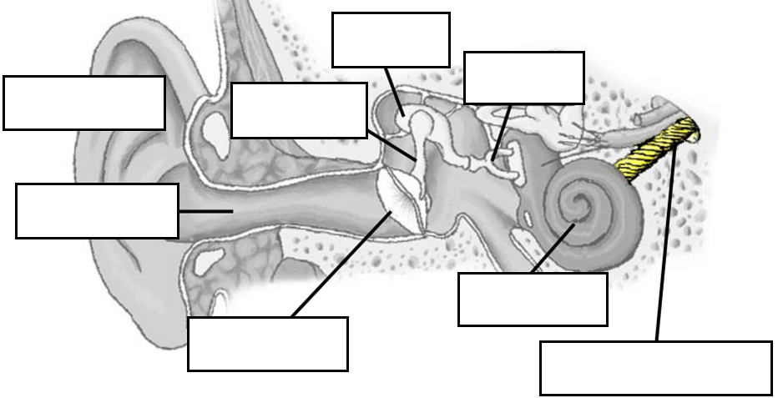

- Balancing - controlled by 3 ___________________ canals in the ear

- Detects _____________ and backward, up and ___________, and _____________________ movements

- Dizzy - ___________ in canals continues to __________ after you stop and ______________ the brain

- Taste

- Tongue

- Papillae - __________ that cover the ____________ surface

- Taste buds - Found in ___________, detect ____________

- Saliva - Water-like __________ that dissolves _______________ in food making them _________________

- Types of Taste

- Bitter – at ___________ of tongue

- Example –

- Sour – on ___________ of tongue

- Example –

- Salty - Along _________ and _________ of tongue

- Example –

- Sweet – at _________ of tongue

- Example –

- Umami - ___________ taste of foods

- Example –

- Smell

- Nose – main organ of ___________

- _______________________ in the top of the nose detect ______________ in the air

- Humans have ___________________ receptor cells in the nose and can recognize ______________different smells

- ______________ nerves send ____________ to brain

- _______ of what we “taste” is actually ___________

- The nose and mouth are _____________ at the _____________

- Touch

- Skin

- The sense organ for _______________

- _________________ organ of the body

- Two layers:

- Epidermis - ______________ layer made of _____________ cells

- Dermis - _______________ layer made of _______________ cells

- Receptors - Most are in the __________________

- Heat receptors – detect ______________

- Cold receptors – detect ______________

- Touch receptors – detect ________________________

- Pressure receptors – detect ___________________________

- Pain receptors – detect _____________, very ____________ to surface of skin

- Hair movement – can feel hairs ____________ without touching __________

- Nerves

- Receptors connect to ____________ throughout the body

- Sensory nerves – ________________ information and send it to the ____________

- Motor nerves – sends messages from ____________ to body to _______________

- Sensitivity - depends a lot on how ______________________ the_________________ area and how ___________ they are

- Sensitive areas

- Fingertips – about _______________touch receptors

- Lips – skin is very ________________

- Not so much…

- Middle _______________, _____________, ___________________

- Using our sense of touch

- Braille - using ____________ dots to represent ______________ and _______________

