Digestive System Labeling Name _________________________________

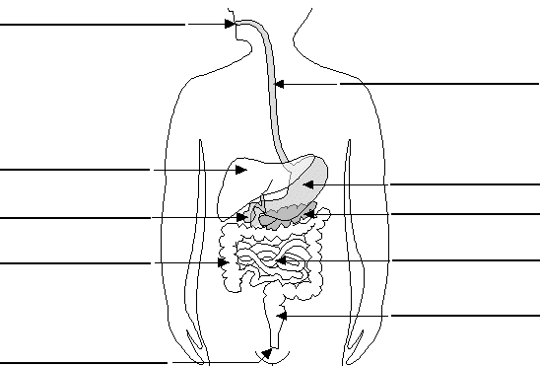

Label the molars, incisors, canines, and premolars on the teeth below.
