Nervous System Labeling Name _________________________
Match the parts of the brain

________1. Cerebellum
________2. Thalamus
________3. Midbrain
________4. Cerebrum
________5. Hypothalamus
________6. Medulla Oblongata
________7. Pons
________8. Brain stem (all letters)
________9. Diencephalon (all letters)

Label the 4 lobes of the brain
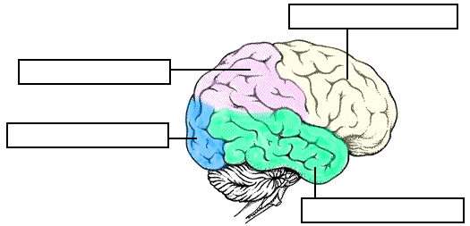
Match the parts of a neuron

_____1. Axon
_____2. Dendrites
_____3. Myelin sheath
_____4. Nucleus
_____5. Cell body
_____6. Synaptic knob
_____7. Node of Ranvier

