Reproductive System Name ________________________________

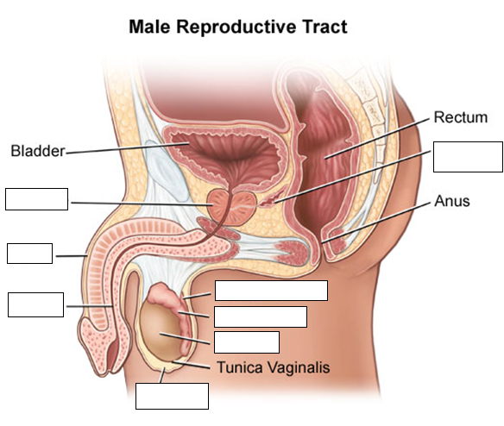

**Female Reproductive Tract**

