Respiratory Labeling Name __________________________

Match the parts of the upper respiratory  _____1. Epiglottis  _____2. Sinuses  _____3. Nostril  _____4. Nasal conchae  _____5. Adenoid  _____6. Tonsil | 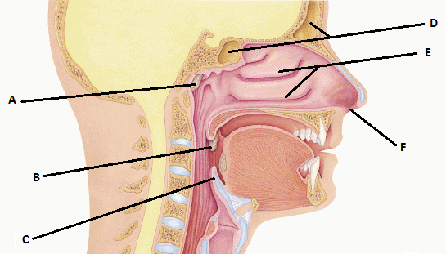

Match the main organs of the respiratory system
_____1. Diaphragm  _____2. Alveoli  _____3. Bronchioles  _____4. Trachea  _____5. Larynx  _____6. Lung  _____7. Bronchi  _____8. Pharynx  _____9. Nasal cavity | 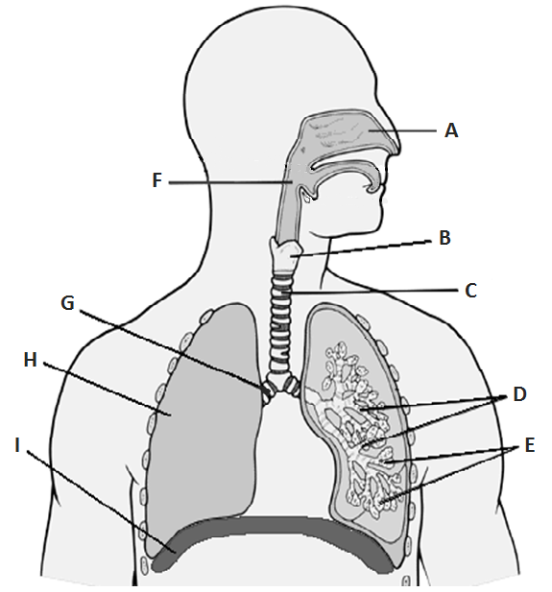
Write out the 10 steps of Inspiration and Expiration

