The Heart Name_______________________________
Label the structures of the heart.

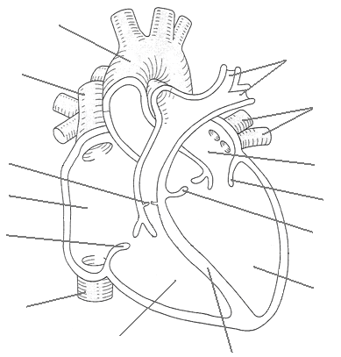

Labe the blood vessels:

